# Hospital Management System

This is a hospital management user interface for managing, monitoring and controlling the system in a Hospital. This application is developed in mySQL, which mainly focuses on basic operations in a hospital like adding new patient information, and updating new information, assigning the doctor for patient. It features a familiar and well thought-out, an attractive online user interface, combined with strong searching Insertion and reporting capabilities.

Technologies used:

Xampp, Sublime text, Visual Studio code

Patient and Doctor Side features:

1. Patients can book appointments with any doctor on the list.

2. Only admin has access to the system.

3. Admin can view/update/cancel already booked appointments if necessary.

4. Doctors and patients’ information can be registered to the system.

5. Manages rooms.

6. Patients can choose whichever room they want according to their needs.

Screenshots:

1. Login Screen

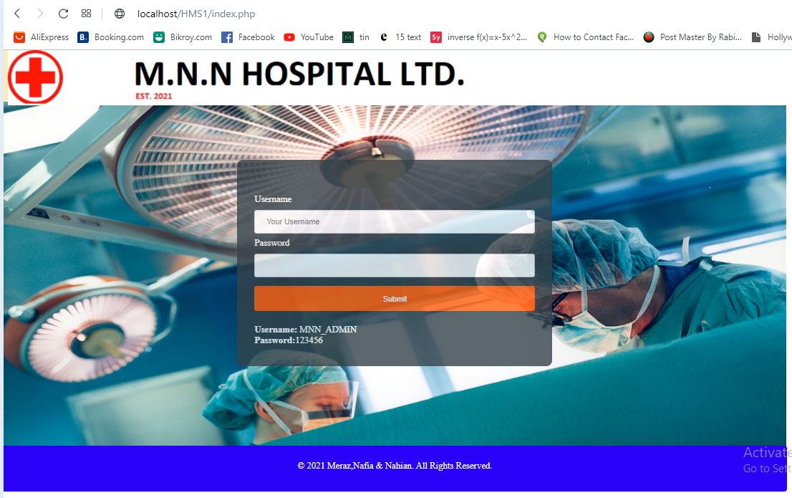

1. Home screen



1. Doctors registering on the system

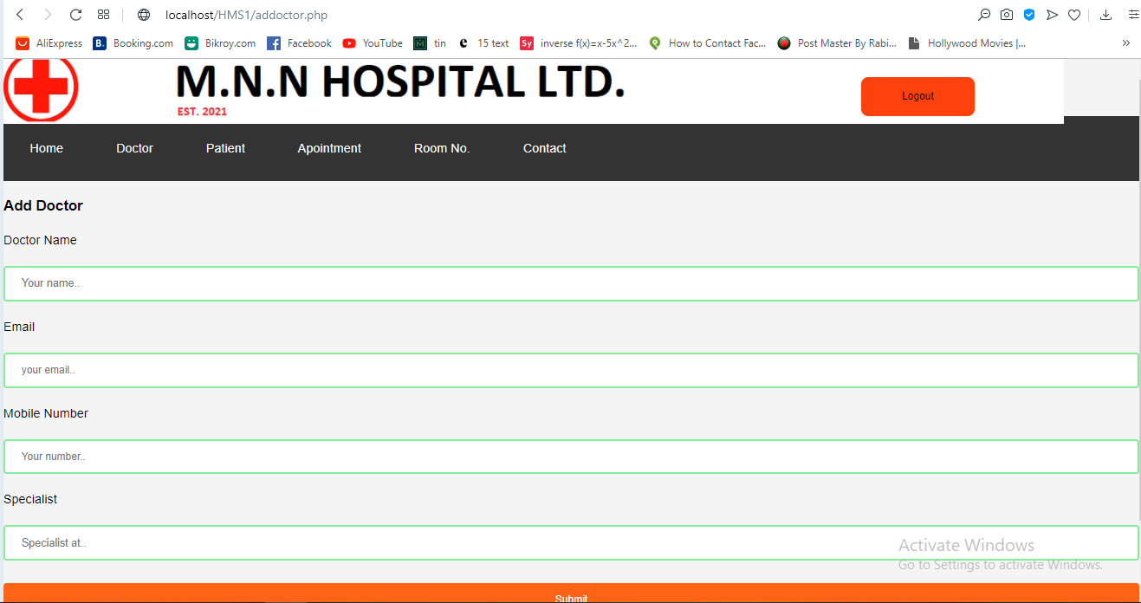

1. Doctors list

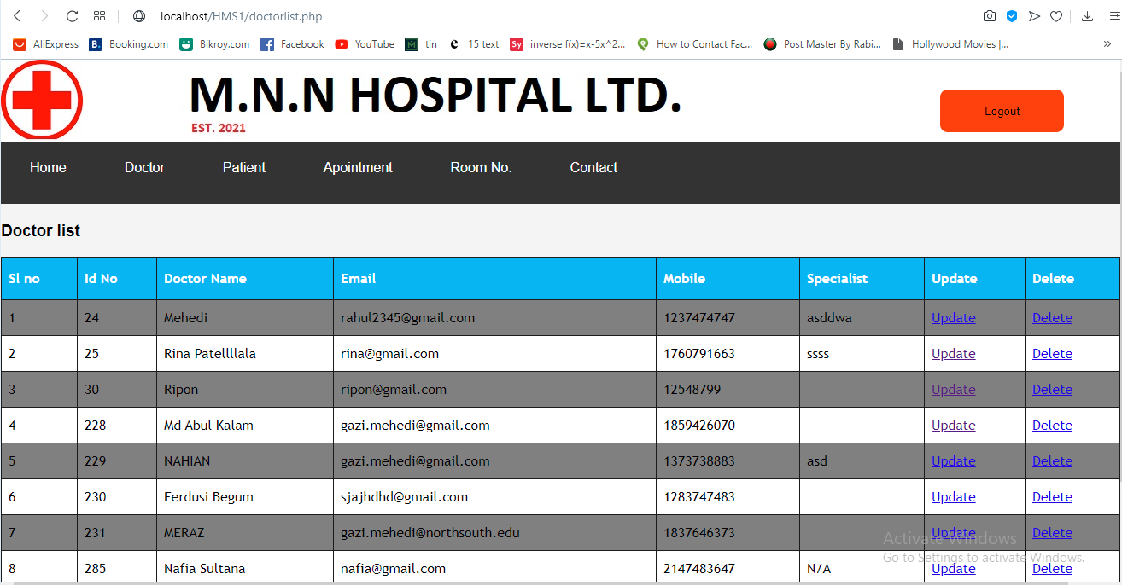

1. Patients registering on the system

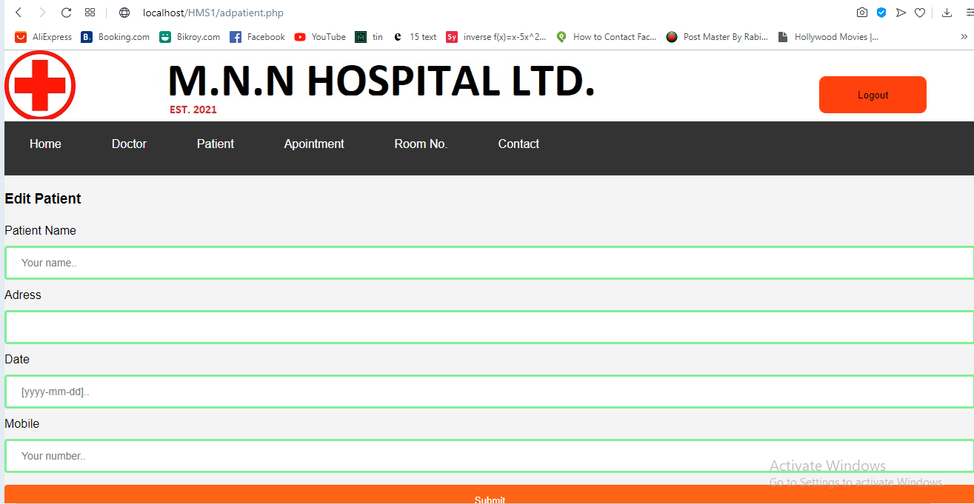

1. Patients list

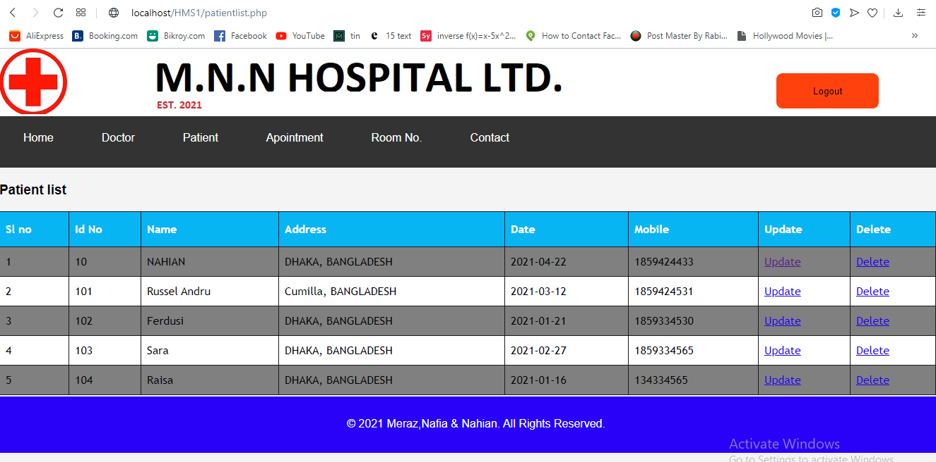

1. Scheduling appointments

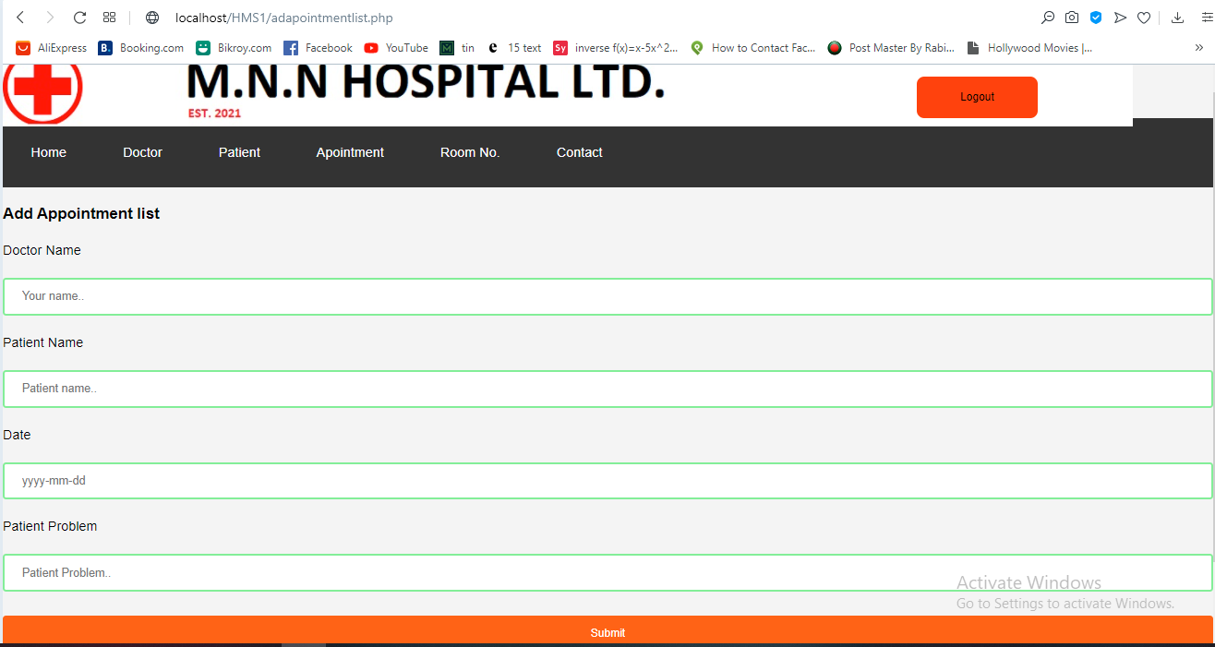

1. Viewing appointment list

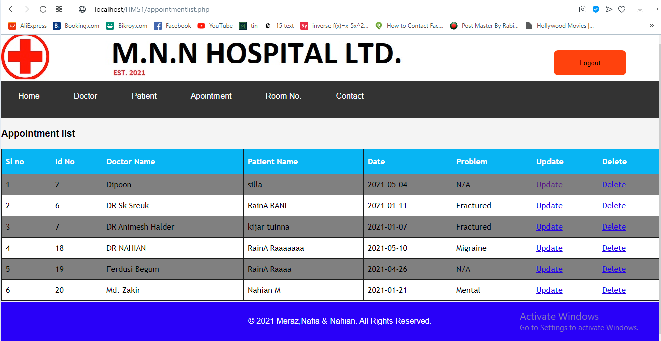

1. Manage Room

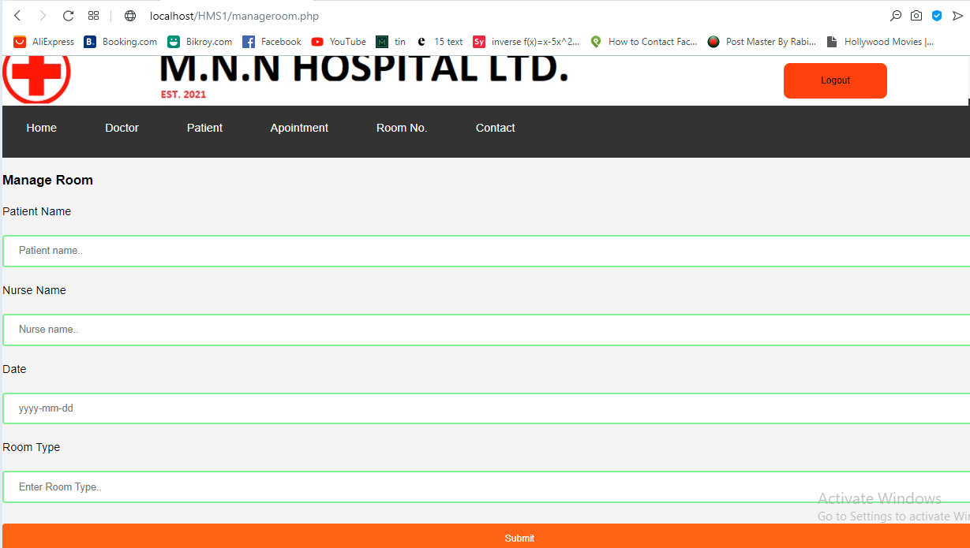

1. Viewing rooms

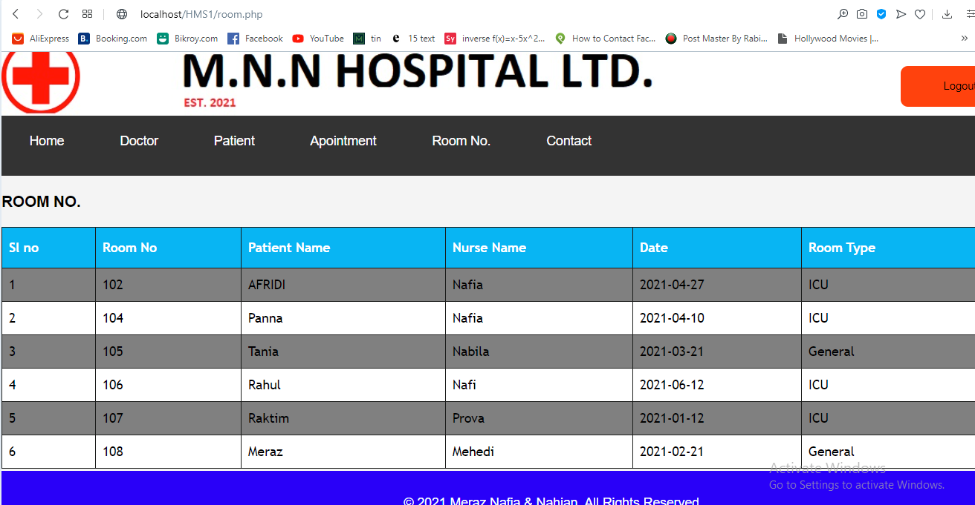

Instructions to run:

1. Copy the file and paste it in htdocs of the xampp folder.
2. Import the database in xampp.
3. Run the database.
4. Access localhost from the browser.
5. For more details check Read Me First.